Nature seen
by scientist

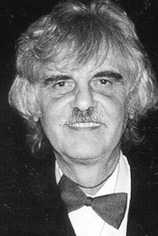

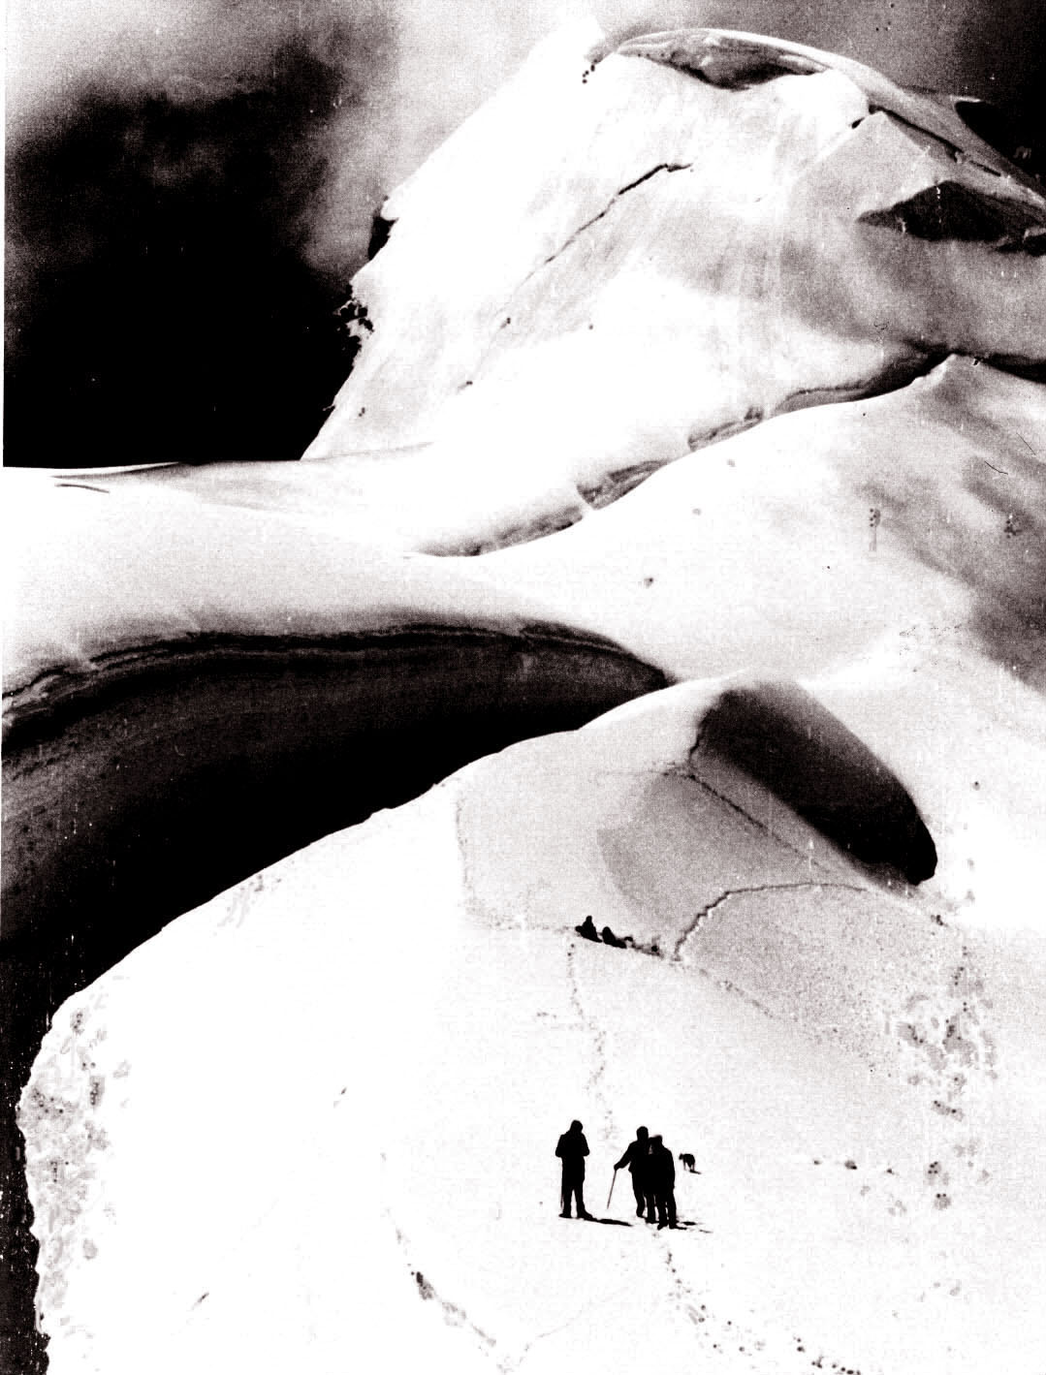

Within the opening there will be inauguration of a new book by
Prof. Jaroslav Šesták, MEng., PhD., DSc,,
(Institute of Physics in Prague)

Science of heat and thermophysical study

just printed by the Publishing House Elsevier, Amsterdam, at the occasion of the International Year of Physics 2005 and the 40th Anniversary of the International Confederation of Thermal Analysis

The sponsorship is undertaken by the companies
Labtech spol. s r. o. a Chromspec spol. s r.o
furnishing various laboratory instruments




Publicizing division of
the Academy of Sciences
of the Czech Republic
Holds under the auspice of its President
Prof. Václav Pačes, RNDr. PhD., DSc,,

Photo exhibition of

Jaroslav Šesták
“Nature seen by scientist”
which opening takes place
on Monday December 5th at 5:30 p.m.
in the Hall of the Academy of Sciences,
Národní str. 3, Praha 1

The honorary guests launching the exhibit:
Prof. Václav Pačes, RNDr. PhD., DSc,,
President of the Academy of Sciences,
Prof. Jiří Málek, MEng. PhD., DSc,,
Rector of the University of Pardubice,
Prof. Josef Průša, MEng., PhD.,
Rector of the West Bohemian University in Pilzen,
Senator Jaromír Štětina,
Representative of the Czech National Parliament.

Photo exhibition is open in working days from 8 a.m. to 6 p.m. from the December 5th to 22nd 2005

